WEEK-3 ASSIGNMENT
Step 1: Setup Data
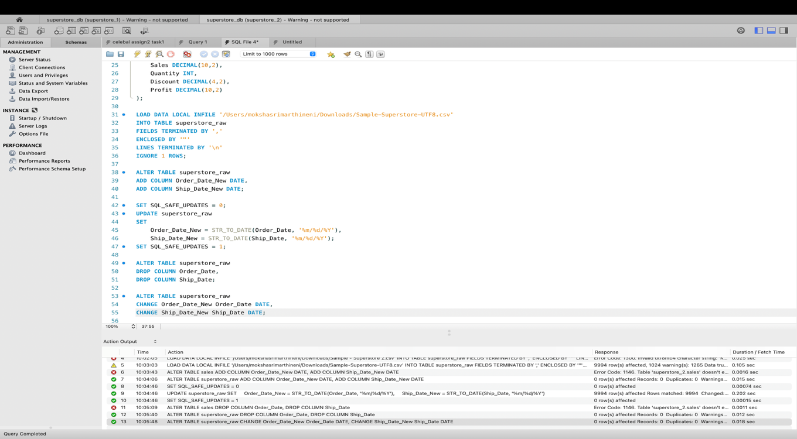
- Here I have imported the dataset into the table named as superstore_raw.
- I have firstly created a table and then imported the data from csv file to the table.
- Next, I have also altered the columns as per the dates order in MySQL.
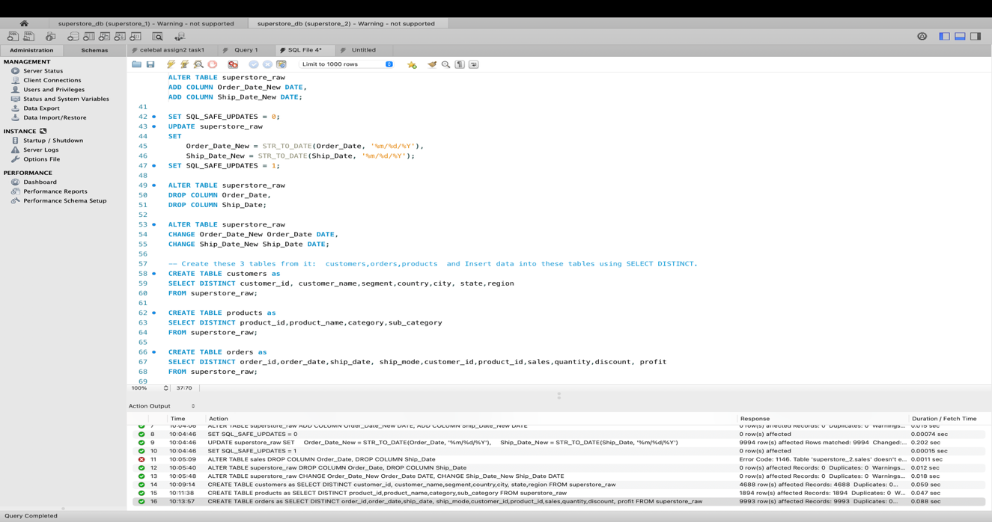
- I have created tables named customers, products and orders.
- I have used SELECT DISTINCT and inserted the data to the tables from superstore_raw table.
Step 2: Perform Required Queries
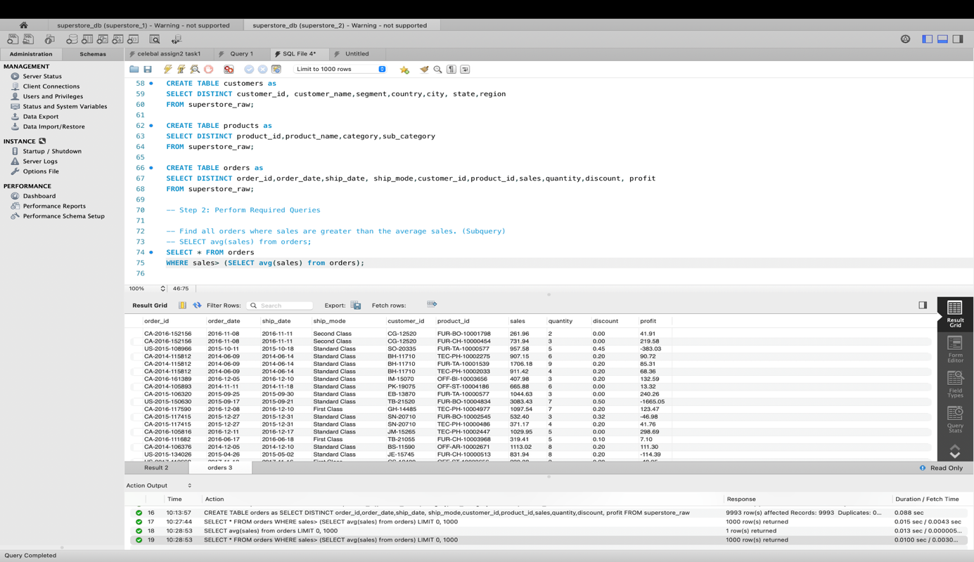
- I have found out the sales that greater than the average sales using subquery.
- So, all the sales greater than 229.85 (average of the sales) are displayed.

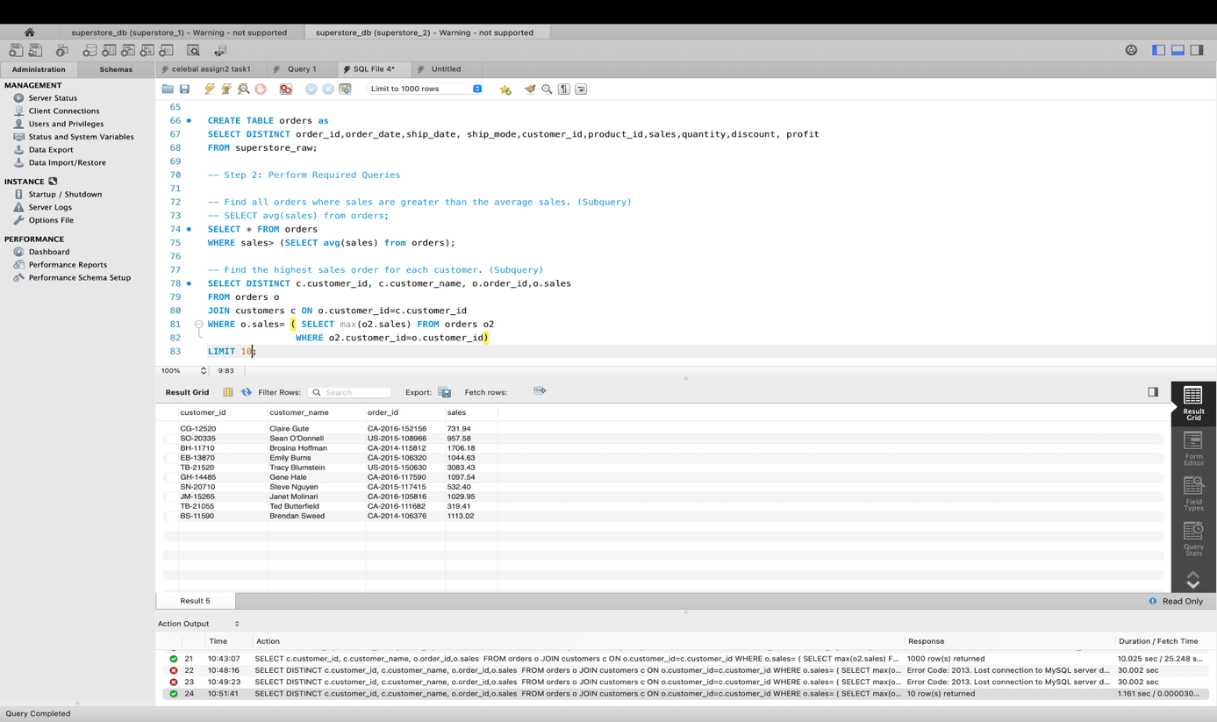
- I have found out the highest sales order for each customer.
- I have joined the orders table and customer table on basis of customer id and used to subquery to find the maximum purchase of a customer.
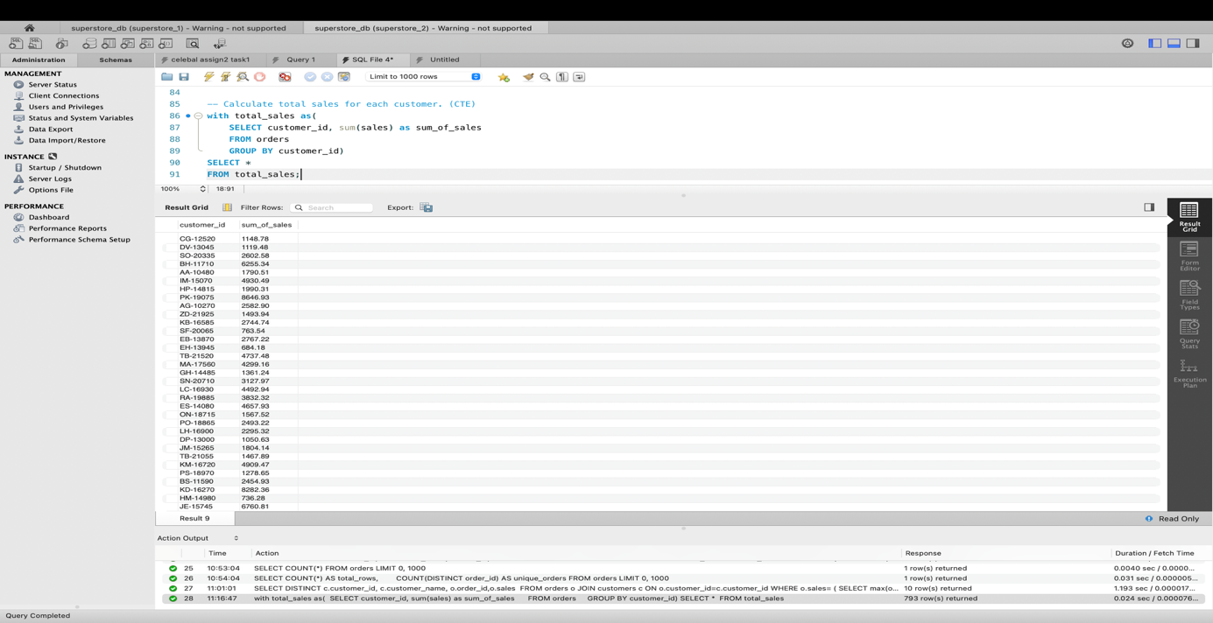
- I have calculated the total sales made by each customer using CTE.
- It groups the records in orders table based on customer id and then calculates the sum of each customer.

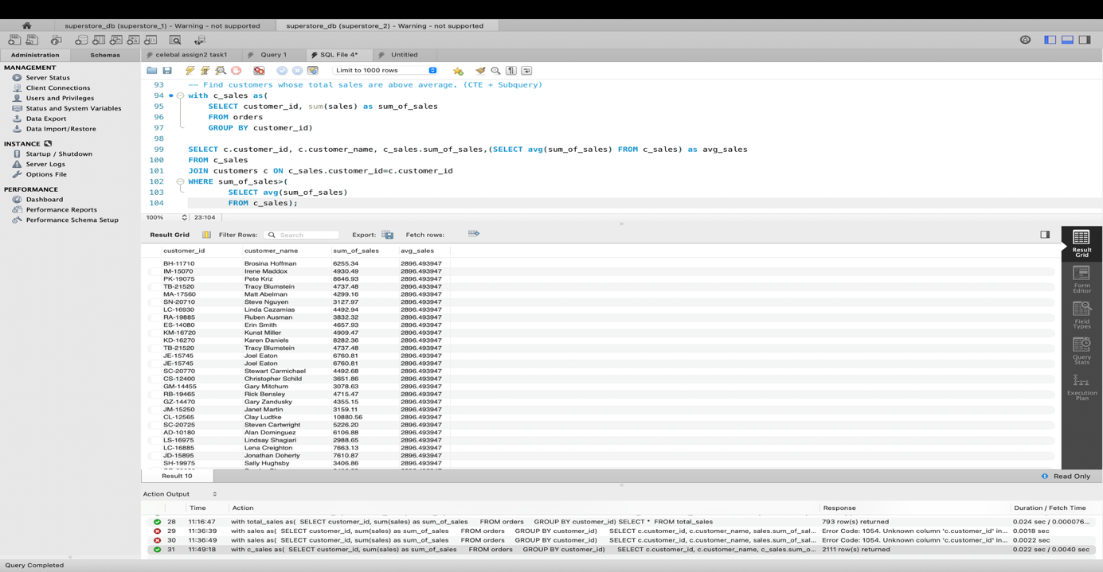
- I have printed the customers whose total sales are above average.
- Firstly I created a CTE with the name c_sales. It calculates total sales of each customer.
- This result is used to join with customer table so that customer name can be extracted.
- The subquery calculates the average of total sales of each customer and where clause filters all the sum of sales greater than average.
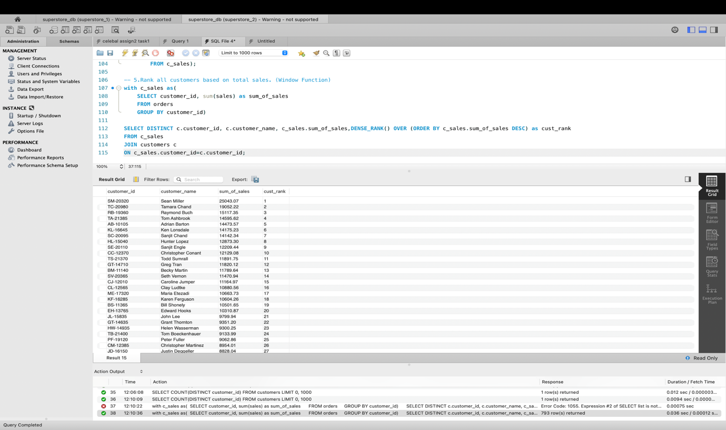
- I have printed rank of all customers based on total sales.
- I have used a CTE named c_sales for calculating sum of sales of each customer.
- Then I have used dense rank to rank the sum of sales of each customer and used join to extract customer name to the output.

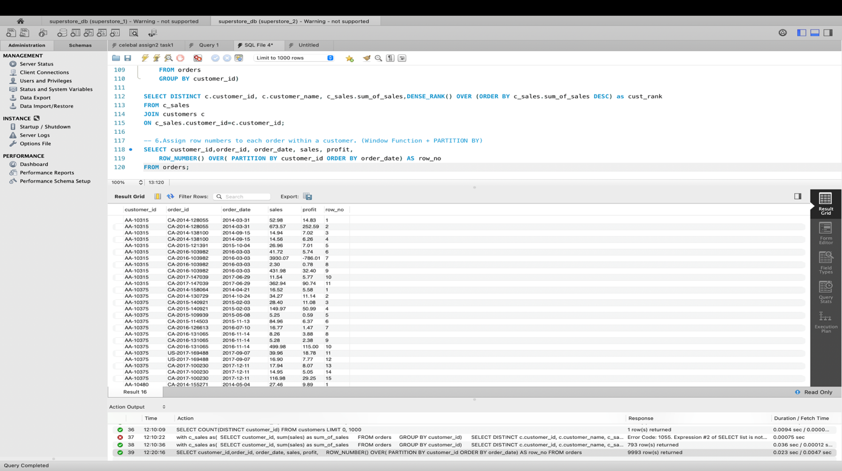
- I have assigned row numbers to each order within a customer.
- I have used window function ROW_NUMBER() and PARTITION to differentiate customer_id.
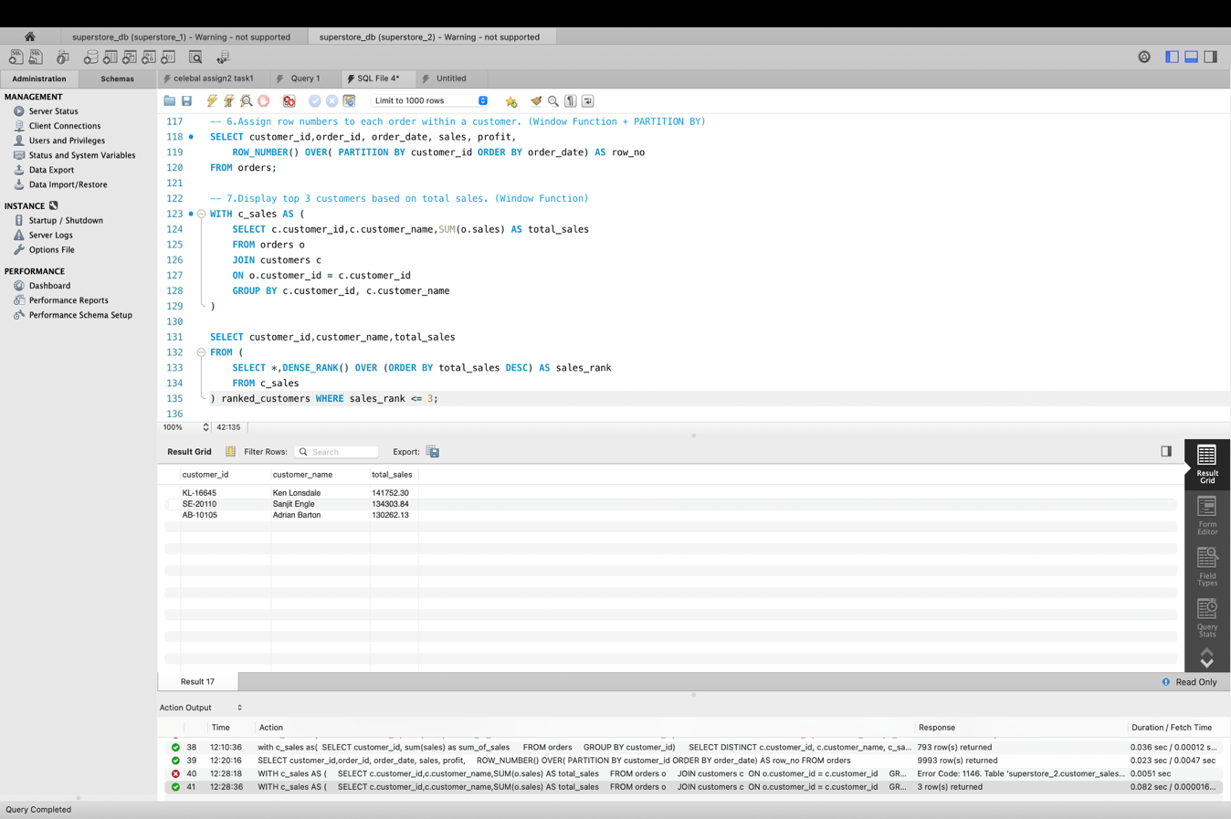
- I have filtered the top 3 customers based on total sales.
- The CTE calculates total sales of each customer.
- The DENSE_RANK() ranks cutomers in descending order of total sales and the top 3 are displayed because of condition after where.
Step 3: Final Combined Query
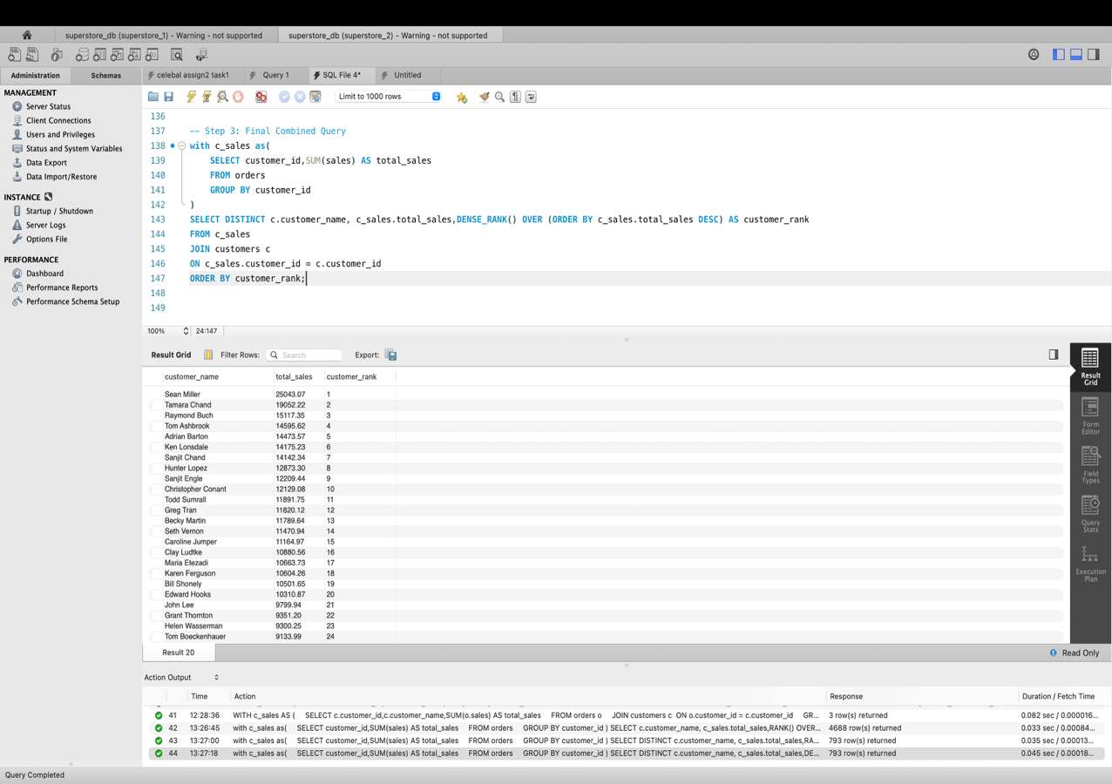

- I have used CTE to find total sales of each customer.
- I have used DENSE_RANK() to give ranking to total sales of customer in decending order.
- I have used join because customer name belongs to customer table and in order to extract the customer name I have used JOIN.
- Lastly I have printed in order of customer rank.

Mini Project: Customer Sales Insights
- Who are the top 5 customers?

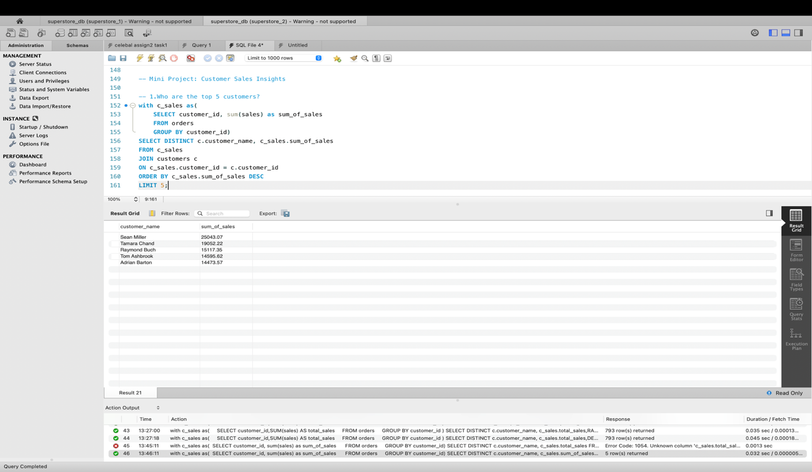

- I have used CTE to calculate sum of sales of each customer.
- Then I have used order by for these sum of sales in descending order to get the top 5 customers.

- Who are the bottom 5 customers?
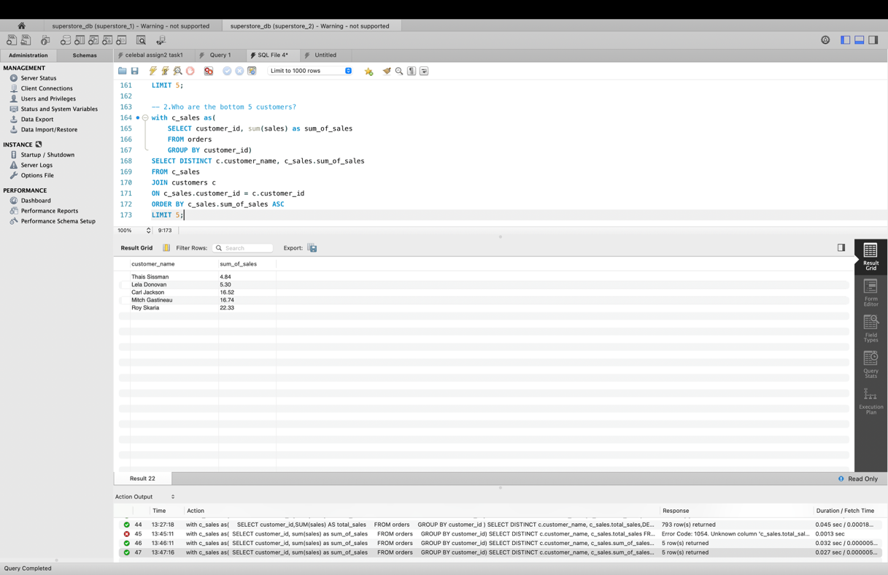
- I have used CTE to calculate sum of sales of each customer.
- Then I have used order by for these sum of sales in ascending order to get the bottom 5 customers.

- Which customers made only one order?
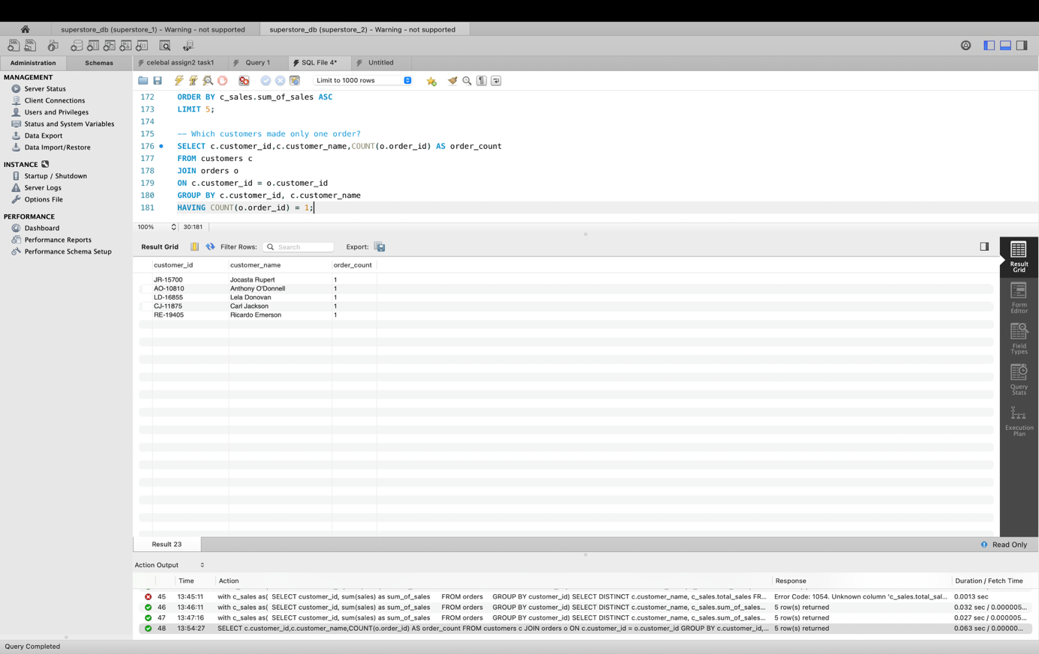
- I have used count() function to get the number of orders made by each customer and used JOIN to join orders table and customer table based on customer_id.
- Which customers have above-average sales?
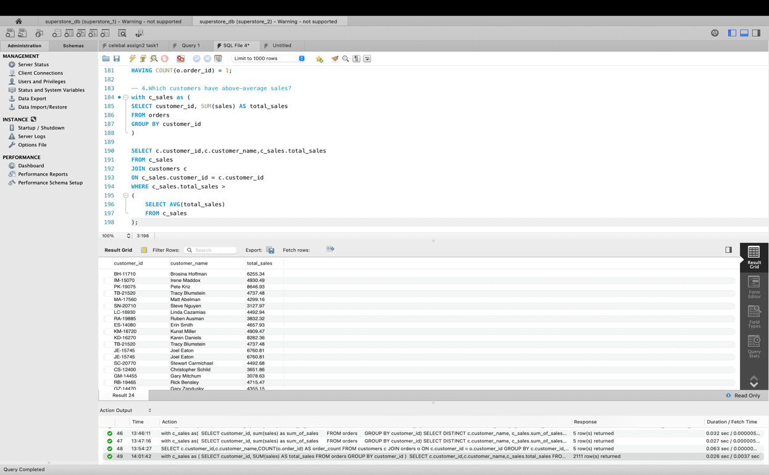
- I have used CTE to calculate sum of sales by each customer
- I have used subquery to find average of the sum of sales made by each customer.
- The filtering takes place at the where clause.

- What is the highest order value per customer?
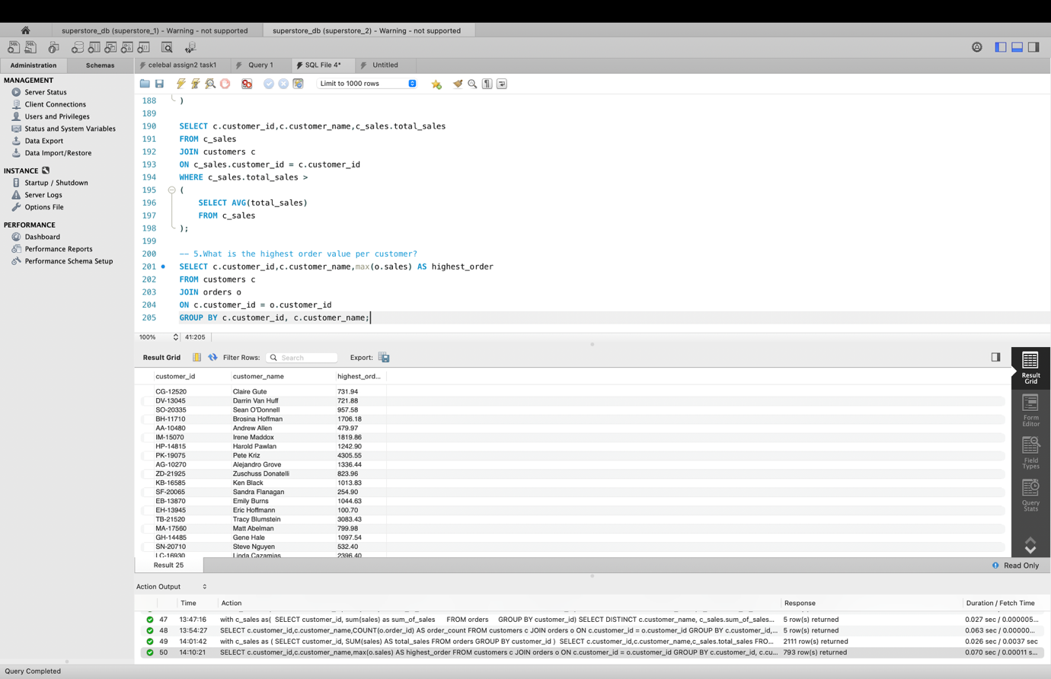
- I have used max() to find the highest order
- I have used JOIN to merge orders and customers table based on customer id.
- This query results in highest order value of each customer.

